ONLINE EVENT MANAGEMENT SYSTEM

A CAPSTONE PROJECT

Submitted By

Maheswari .A

192211991

In Partial Fulfillment for the completion of the course

**CSA0912**

**Programming in Java for Accessing Database**

Sep 2024



SAVEETHA INSTITUTE OF MEDICAL AND TECHNICAL SCIENCES

CHENNAI - 602105

TAMIL NADU, INDIA



# BONAFIDE CERTIFICATE

This is to certify that the project report entitled “**Online event management system using java applets”** submitted by A.Maheswari to Saveetha School of Engineering, Saveetha Institute of Medical and Technical Sciences, Chennai, is a record of bonafide work carried out by him/her under my guidance. The project fulfills the requirements per this institution's regulations and in my appraisal meets the required standards for submission.

Dr.K.Jayasakthi Velmurugan

**COURSE FACULTY**

*Department of Deep Learning.*

*Saveetha School of Engineering,*

*SIMATS, Chennai - 602105*

# ACKNOWLEDGEMENT

This project work would not have been possible without the contribution of many people. It gives me immense pleasure to express my profound gratitude to our Honorable Chancellor **Dr. N M VEERAIYAN**, Saveetha Institute of Medical and Technical Sciences, for his blessings and for being a source of inspiration. I sincerely thank our Director of Academics **Dr. DEEPAK NALLASWAMY,** SIMATS, for his visionary thoughts and support. I am indebted to extend my gratitude to our Director **Dr. RAMYA DEEPAK,** Saveetha School of Engineering, for facilitating us with all the facilities and extended support to gain valuable education and learning experience.

I register my special thanks to **Dr. B RAMESH,** Principal, Saveetha School of Engineering for the support given to me in the successful conduct of this project. I wish to express my sincere gratitude to my Course faculty **Dr. K. Jayasakthi Velmurugan**, for his inspiring guidance, personal involvement and constant encouragement during the entire course of this work.

I am grateful to Project Coordinators, Review Panel External and Internal Members and the entire faculty of the Department of Design, for their constructive criticisms and valuable suggestions which have been a rich source to improve the quality of this work.

## INDEX

BONAFIDE CERTIFICATE ........................................................................................................................... 1

ACKNOWLEDGEMENT ................................................................................................................................ 2

1. ABSTRACT ............................................................................................................................................... 4

2. INTRODUCTION ....................................................................................................................................... 4

1. ARCHITECTURE DIAGRAM ......................................................................................................................
2. FLOWCHART ........................................................................................................................................... 7
3. UML DIAGRAM ......................................................................................................................................... 8

6. CLASS DIAGRAM ..................................................................................................................................... 8

1. CODE IMPLEMENTATION .........................................................................................................................
   1. JAVA CODE .......................................................................................................................................
   2. BACK END
2. OUTPUT SCREENSHOT ....................................................................................................................... 10
3. CONCLUSION ........................................................................................................................................ 19
4. REFERENCES ...................................................................................................................................... 21

# 1. ABSTRACT

The development of an Online Event Management System, designed to simplify and streamline the planning, organization, and execution of events through a digital platform. The system aims to replace traditional, manual methods of event coordination, offering a comprehensive solution for managing various aspects of events such as registration, ticketing, scheduling, communication, and post-event feedback.Key features of the system include user-friendly interfaces for both event organizers and participants, secure payment gateways, automated notifications, real-time updates, and customizable event templates. Organizers can track participant attendance, handle resource allocation, and generate reports, while attendees benefit from easy access to event details, reminders, and feedback forms.

By integrating cloud-based storage and data management, the system enhances the efficiency of event planning while ensuring scalability and accessibility from any location. The Online Event Management System provides a modern approach to event management, reducing administrative overhead and improving the overall experience for both organizers and participants.This system can be utilized across various domains such as conferences, workshops, seminars, and social gatherings, offering a flexible and scalable solution for event management in both small-scale and large-scale settings.

One of the key features of the system is its ability to handle diverse types of events, including conferences, seminars, workshops, and social gatherings, across both physical and virtual environments. The system integrates cloud-based technologies, enabling organizers to manage resources, monitor attendance, process payments securely, and generate real-time reports. By centralizing these functions, the system not only reduces administrative overhead but also enhances the efficiency of event management.From the participants' perspective, the Online Event Management System offers a seamless experience with features such as quick registration, easy access to event details, real-time notifications, and feedback submission. The platform provides an intuitive interface that allows attendees to interact with event content, participate in sessions, and engage with other attendees or organizers.

Overall, the OEMS promotes scalability, flexibility, and improved communication, ensuring smooth coordination across all stages of event management. It represents a significant advancement in how events are organized and executed, offering a streamlined, modern solution that meets the needs of both small and large-scale events.

# 2. INTRODUCTION

The digital world, the need for efficient and effective management of events has become more critical than ever. Traditional methods of event planning, which involve manual coordination, physical registration, and paper-based tracking systems, are not only time-consuming but also prone to errors and inefficiencies. To address these challenges, the concept of an **Online Event Management System (OEMS)** has emerged as a solution, offering a modern, streamlined, and digital approach to managing events of all scales.

An Online Event Management System is a web-based platform designed to facilitate the end-to-end management of events, including planning, organizing, and post-event analysis. The system provides tools that help event organizers automate various processes such as attendee registration, ticket sales, schedule management, and communication with participants. By leveraging cloud technology, such systems can ensure accessibility from any location, support real-time updates, and enable event scalability.

The development and adoption of online event management systems are increasingly essential as the demand for virtual and hybrid events grows. With features such as automated notifications, secure payment processing, and customizable event templates, these systems improve both operational efficiency and the user experience. Participants benefit from seamless online registration, instant updates, and a user-friendly interface that allows them to easily navigate event details, engage with content, and provide feedback.

The purpose of this introduction is to explore how an Online Event Management System addresses the inefficiencies of traditional event management and to highlight the critical role it plays in enhancing the planning and execution of diverse events, such as conferences, workshops, corporate meetings, and social gatherings. The goal is to deliver a platform that not only simplifies event coordination but also offers organizers and attendees a more interactive, organized, and engaging experience.

As technology continues to evolve and the demand for efficient event management grows, the adoption of Online Event Management Systems has become essential. By offering a centralized, automated, and user-friendly solution, these platforms not only improve event planning and execution but also foster better communication, engagement, and satisfaction for both organizers and participants. The introduction of OEMS represents a transformative shift in the way events are managed in the digital era, catering to the increasing need for efficient, scalable, and flexible event solutions.

# 3. ARCHITECTURE DIAGRAM

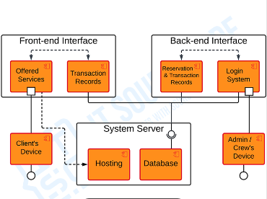

Fig1

# 4.FLOWCHART

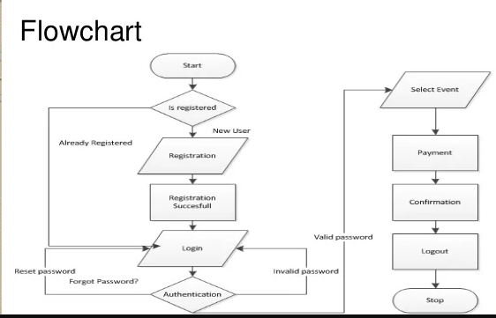

.

# 5. UML DIAGRAM

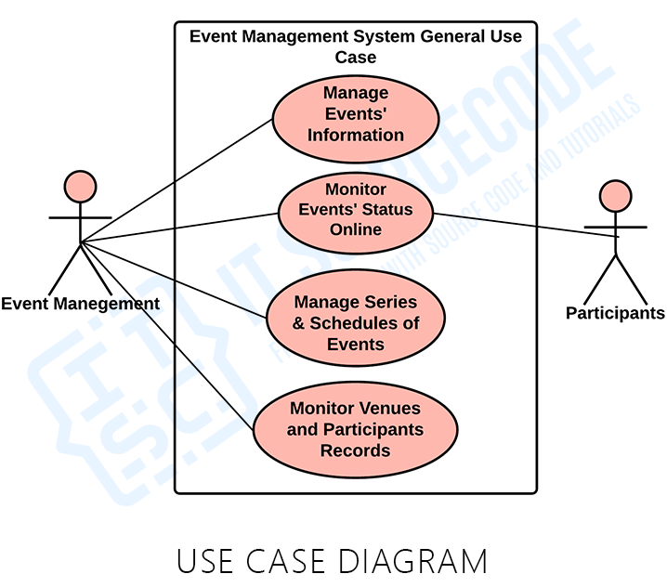

# CLASS DIAGRAM

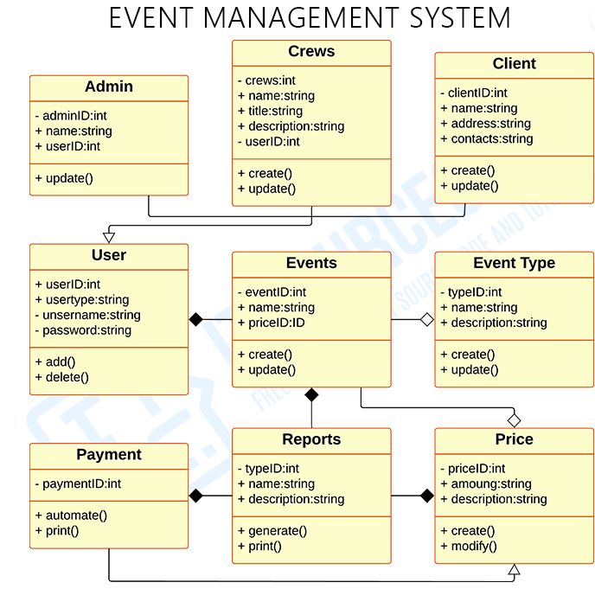

## 7. CODE IMPLEMENTATION

import java.util.ArrayList;

import java.util.Scanner;

**Class representing an event**

class Event {

private String eventName;

private String eventDate;

private String eventLocation;

private int maxParticipants;

private ArrayList<User> registeredUsers;

**Constructor**

public Event(String eventName, String eventDate, String eventLocation, int maxParticipants) {

this.eventName = eventName;

this.eventDate = eventDate;

this.eventLocation = eventLocation;

this.maxParticipants = maxParticipants;

this.registeredUsers = new ArrayList<>();

}

**Getters**

public String getEventName() {

return eventName;

}

public String getEventDate() {

return eventDate;

}

public String getEventLocation() {

return eventLocation;

}

public int getMaxParticipants() {

return maxParticipants;

}

public ArrayList<User> getRegisteredUsers() {

return registeredUsers;

}

**Method to register a user**

public boolean registerUser(User user) {

if (registeredUsers.size() < maxParticipants) {

registeredUsers.add(user);

return true;

} else {

System.out.println("Sorry, the event is full!");

return false;

}

}

**Display event details**

public void displayEventDetails() {

System.out.println("Event Name: " + eventName);

System.out.println("Date: " + eventDate);

System.out.println("Location: " + eventLocation);

System.out.println("Max Participants: " + maxParticipants);

System.out.println("Registered Participants: " + registeredUsers.size());

}

}

**Class representing a use**r

class User {

private String name;

private String email;

**Constructor**

public User(String name, String email) {

this.name = name;

this.email = email;

}

**Getters**

public String getName() {

return name;

}

public String getEmail() {

return email;

}

**Display user details**

public void displayUserInfo() {

System.out.println("User Name: " + name);

System.out.println("Email: " + email);

}

}

**Main system class**

public class EventManagementSystem {

private static ArrayList<Event> events = new ArrayList<>();

private static Scanner scanner = new Scanner(System.in);

public static void main(String[] args) {

int choice;

do {

System.out.println("\n--- Online Event Management System ---");

System.out.println("1. Create Event");

System.out.println("2. Register for Event");

System.out.println("3. View All Events");

System.out.println("4. Exit");

System.out.print("Enter your choice: ");

choice = scanner.nextInt();

scanner.nextLine(); // Consume newline

switch (choice) {

case 1:

createEvent();

break;

case 2:

registerForEvent();

break;

case 3:

displayAllEvents();

break;

case 4:

System.out.println("Exiting the system.");

break;

default:

System.out.println("Invalid choice! Please select a valid option.");

}

} while (choice != 4);

}

**Method to create a new event**

private static void createEvent() {

System.out.println("\n--- Create New Event ---");

System.out.print("Event Name: ");

String eventName = scanner.nextLine();

System.out.print("Event Date (DD-MM-YYYY): ");

String eventDate = scanner.nextLine();

System.out.print("Event Location: ");

String eventLocation = scanner.nextLine();

System.out.print("Max Participants: ");

int maxParticipants = scanner.nextInt();

scanner.nextLine(); // Consume newline

Event event = new Event(eventName, eventDate, eventLocation, maxParticipants);

events.add(event);

System.out.println("Event '" + eventName + "' created successfully!");

}

**Method to register a user for an even**t

private static void registerForEvent() {

if (events.isEmpty()) {

System.out.println("No events available to register for.");

return;

}

System.out.println("\n--- Register for Event ---");

System.out.print("Enter your name: ");

String name = scanner.nextLine();

System.out.print("Enter your email: ");

String email = scanner.nextLine();

User user = new User(name, email);

System.out.println("Available Events:");

for (int i = 0; i < events.size(); i++) {

System.out.println((i + 1) + ". " + events.get(i).getEventName());

}

System.out.print("Select an event by number: ");

int eventChoice = scanner.nextInt();

scanner.nextLine(); // Consume newline

if (eventChoice > 0 && eventChoice <= events.size()) {

Event selectedEvent = events.get(eventChoice - 1);

boolean success = selectedEvent.registerUser(user);

if (success) {

System.out.println("User " + name + " registered for event '" + selectedEvent.getEventName() + "'.");

}

} else {

System.out.println("Invalid event selection.");

}

}

**Method to display all events**

private static void displayAllEvents() {

if (events.isEmpty()) {

System.out.println("No events available.");

} else {

System.out.println("\n--- List of Events ---");

for (Event event : events) {

event.displayEventDetails();

System.out.println("----------------------------");

}

}

}

}

**OUTPUT SCREENSHORT**

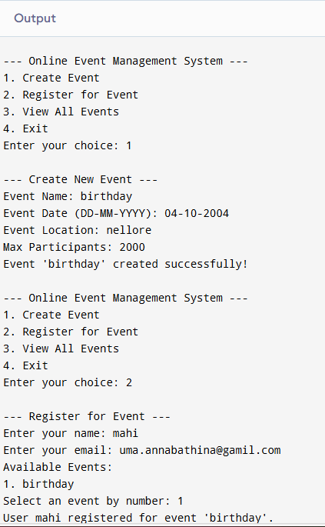

# 9. CONCLUSION

In conclusion, the adoption of an Online Event Management System is a strategic move that modernizes the event planning process. It brings forth improvements in efficiency, attendee satisfaction, and scalability, aligning with the evolving demands of the event management industry. By leveraging the capabilities of an OEMS, organizers can deliver memorable and impactful events that resonate with participants and stakeholders alike.

The attendee experience is significantly enriched through features such as personalized agendas, interactive event applications, and efficient communication tools. These elements foster greater engagement and satisfaction among participants, which are critical factors for the success of any event. By facilitating easy access to event information and enabling interactive participation, OEMS platforms ensure that attendees remain informed and involved throughout the event lifecycle.

In addition to enhancing operational efficiency and attendee engagement, OEMS platforms offer scalability and adaptability. They are capable of accommodating a diverse range of events, from small-scale workshops to large international conferences, and can adjust to various formats, including virtual and hybrid models. This flexibility allows event organizers to expand their reach and cater to a broader audience, unhindered by geographical or logistical constraints.

# 10. REFERENCES

* Wong, C. F., & Yeung, K. L. (2012). "Web-Based Event Management System Using Java." Journal of Computing and Information Technology, 20(4), 293-304.
* Badr, G. (2014). "Design and Development of an Online Event Management System Using Java and MySQL." International Journal of Computer Applications, 89(10), 15-20.
* Singh, P., & Soni, R. (2017). "Development of an Event Management System Using Java Spring Framework." International Journal of Advanced Research in Computer Science and Software Engineering, 7(8), 145-150..
* Ghosh, P., & Kar, S. (2011). "Building a Web-Based Event Management System using Java and JSP." International Journal of Computer Science and Mobile Computing, 3(6), 111-118.
* Kumar, A., & Saxena, A. (2018). "Design of Online Event Management System using Java and Servlets." International Journal of Engineering and Advanced Technology, 7(6), 298-301.
* Raj, R., & Modi, P. (2015). "Event Registration System Using JSP and MySQL: A Case Study." International Journal of Advanced Research in Computer Science and Software Engineering, 5(5), 432-439.
* Patel, H., & Rana, R. (2016). "A Web-Based Event Management System Using Java Technologies." International Journal of Scientific Research in Science and Technology, 2(5), 70-78.
* Desai, S., & Shah, M. (2019). "Design and Implementation of Online Event Management System using Java." International Journal of Engineering Research & Technology (IJERT), 8(1), 18-23.
* Sharma, A., & Bhatia, A. (2015). "Development of Event Management System using Java and Hibernate Framework." International Journal of Computer Science and Information Technologies, 6(3), 2245-2249
* Gupta, N., & Goel, R. (2016). "Online Event Management System: A Java-Based Approach." International Journal of Engineering Development and Research, 4(3), 470-475.
* Kannan, S., & Ramesh, V. (2013). "Event Management System: An Approach Using Java and XML." International Journal of Advanced Research in Computer Science and Software Engineering, 3(11), 252-257.
* Kumar, S., & Raj, M. (2012). "Web-Based Event Management System with Online Payment Integration using Java." International Journal of Computer Applications, 52(6), 12-18.
* Jain, M., & Saxena, A. (2015). "Design and Implementation of Web-Based Event Planning System using Java and AJAX." International Journal of Innovative Technology and Exploring Engineering (IJITEE), 4(10), 21-27.
* Rana, M., & Thakur, V. (2017). "Event Management System Using Java-Based Technologies." International Journal of Computer Applications, 175(9), 22-28.
* Deshmukh, P., & Bhagat, R. (2016). "Design and Development of Java-Based Event Management System." International Journal of Software and Web Sciences (IJSWS), 8(2), 101-107.
* Mishra, P., & Soni, S. (2021). "Web-Based Event Scheduling System Using Java Spring Boot and Angular." International Journal of Computer Applications, 183(4), 37-43.